**SoftPro® Static Elbow**

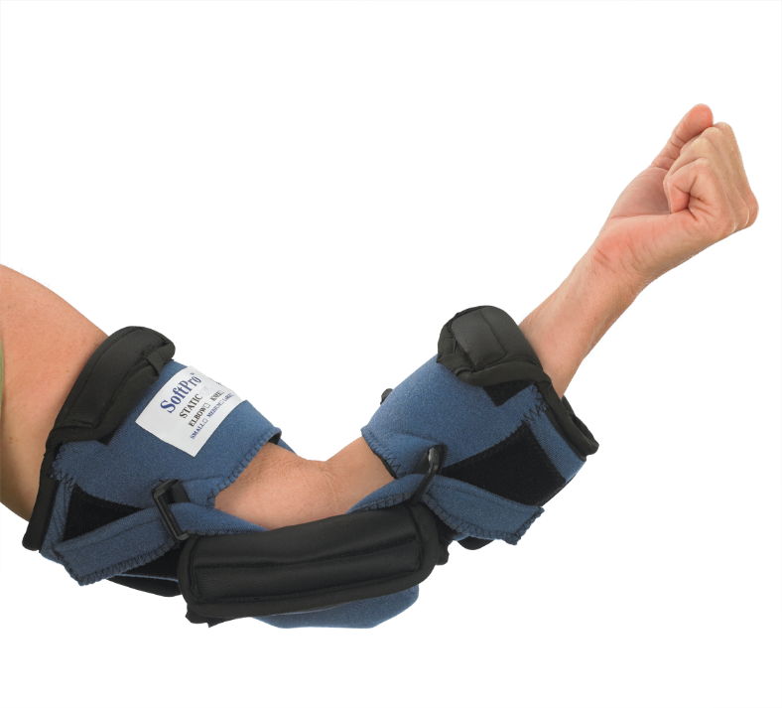

* **Treats mild to moderate contractures of the elbow**
* **Provides 3 point progressive extension stretch**
* **Easily adjustable single setting hinge**

